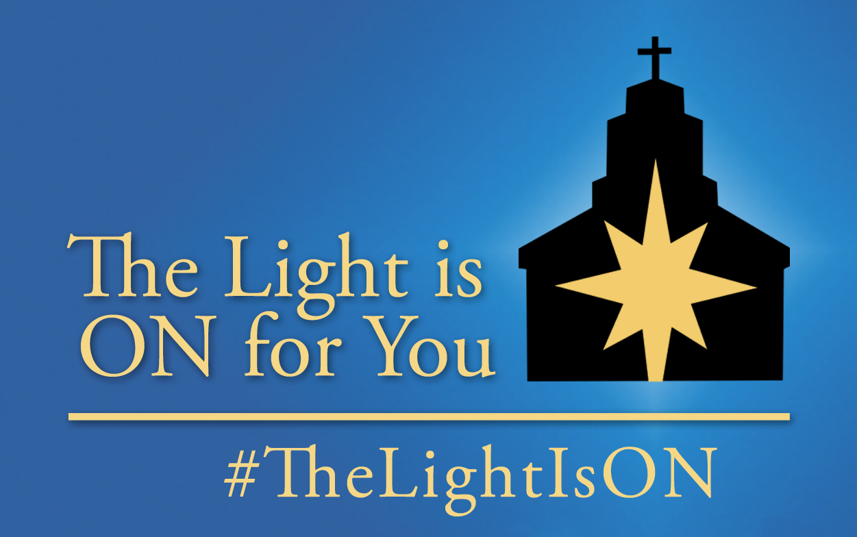

The Light is ON Toolkit
Implementation Guide 2017

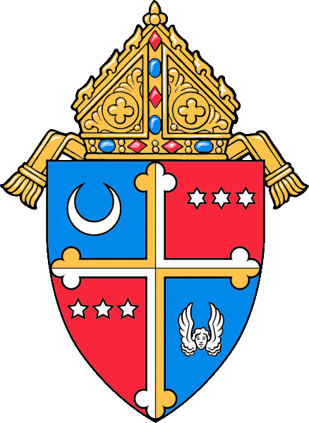
The Archdiocese of Washington

The Diocese of Arlington

TheLightisON.org | LaLuzENCENDIDA.org

#TheLightIsON

Introduction to The Light is ON 2017

For over a decade, The Light is ON has helped parishes reach out to the peripheries to help practicing and inactive Catholics receive God’s mercy and forgiveness in the Sacrament of Reconciliation. By opening your parish doors and offering Confession and prayer on Wednesday evenings during Lent, you join in the shared commitment from parishes in the Archdiocese of Washington and the Diocese of Arlington to “keep the light on”. While this initiative may be very familiar to us it is important to remember that for many people this is the first time they have ever heard of The Light is ON or considered coming back to Confession. Together, we continue to raise awareness for God’s mercy and make it easier for practicing and inactive Catholics to receive the graces of the Sacrament this Lent and celebrate the Easter season. This toolkit will help you integrate The Light is ON into your parish and school communities, extend the welcoming arms of your parish, and spread the Good News of Christ’s mercy to those in your greater community who still need to hear or re-hear the message.

On behalf of the Archdiocese of Washington and the Diocese of Arlington, thank you in advance for your role in keeping the light on this Lent across the entire DC area. If you have any questions about implementing The Light Is ON in your parish, feedback on the initiative, or if you need to request additional resources, please contact:

For the Archdiocese of Washington:
Jonathan Lewis, Director of Evangelization, Youth and Young Adult Initiatives, lewisj@adw.org (301) 853-4559

For the Diocese of Arlington:
John Knutsen, Coordinator of Adult Faith Formation, j.knutsen@arlingtondiocese.org (703) 841-3802

The Light is ON Parish Toolkit Outline:

- Archdiocese of Washington 2017 Goals for The Light is ON
- Four Best Practices for The Light Is ON
- A Summary of The Light is ON Printed Resources
- A Guide for Conducting a “How to Go to Confession” Workshop
- Five Sample Bulletin and Pulpit Announcements
- Five Sample Intercessions
- Announcement for Light The City on March 4th with Cardinal Wuerl

All of the content of the toolkit is available in English and Spanish. So that you can cut and paste more easily, all of these materials may also be found electronically at www.TheLightIsON.org and www.LaLuzENCENDIDA.org.
Archdiocese of Washington 2017 Goals for The Light is ON

- Personal invitation to Confession through word of mouth and Lenten invitation cards

The Archdiocese Central Pastoral Administration will serve parishes by…
- Designing and delivering invitation cards, Confession Pew Cards, and Examen Cards to all parishes before Ash Wednesday
- Creating social media content that encourages Catholics to share why Confession is important to them
Parishes are encouraged to…
- Prioritize Ash Wednesday as an evangelizing moment by preaching in a special way about Confession, and handing out Confession invitation cards, Confession Pew Cards and Examen Cards to parishioners
- Share Confession Invitation Cards and other Lenten and Confession resources with families in schools/religious education, and those who are no longer active in the parish with a personal encouragement to celebrate Confession this Lent
- Offer a personal challenge to your parish that every Catholic go to Confession this Lent as a part of their Lenten observance
- Ask parishioners to invite someone to join them for confession on a Wednesday evening during Lent
- Ask all parish groups and ministries to participate together at one TLIO Wednesday evening or at another time confession is offered at the parish
- Ask parish leaders to be present on Wednesday nights to create a welcoming environment as newcomers come to the parish for prayer and confession

- Increased visibility of Confession through a “Confession finder” map on TheLightisON.org

The Archdiocese Central Pastoral Administration will serve parishes by…
-Developing a “confession finder” map of all parishes across the Archdiocese of Washington on thelightisON.org
- Creating county-specific bulletin inserts featuring parish confession times across local counties and unique county webpages for confession times and locations in your region (e.g. thelightisON.org/MoCo)
- Writing and securing radio and digital advertising that is geo-targeted to different regions across the Archdiocese directing them to your county-specific webpages
- Purchasing billboards in Southern Maryland to increase local visibility of TheLightisON.org
- Posting regularly across all Archdiocesan social media platforms encouraging Catholics to celebrate Confession in their parish this Lent
Parishes are encouraged to…
- Share the link to the “Confession finder” map on your parish website
- Utilize the Digital Toolkit to share TLIO logo and sample posts on your parish social media page and website
- Utilize TLIO Toolkit by creating a corner in your parish bulletin for weekly reflections, weekly pulpit announcements, Prayers of the Faithful, etc.
- Additional times for Confession on Wednesday evenings and throughout the week

The Archdiocese Central Pastoral Administration will serve parishes by…
- Providing Confession at large-scale Archdiocesan events
- Creating print and digital resources that highlight the various opportunities in each county to go to Confession
Parishes are encouraged to…
- Continue to offer confession on Wednesday evenings
- Consider finding a creative additional confession time to reach those who do not typically celebrate the Sacrament in your parish community (e.g. during religious education, during or after Stations of the Cross, on Sunday before or after Masses, at large parish events, etc.)
- Consider increasing the total number of hours confession is offered each week

Five Best Practices for The Light Is ON
- Create a Welcoming Environment:
- Create an environment that makes your church most welcoming for newcomers, for example:
  - Turn on the heat 30min before if your church gets cold
  - Have the church well lit inside and out
  - Have the front of the Church wide open If possible
- Consider offering Adoration of the Blessed Sacrament during The Light is ON
- Invite a different parish organization or ministry to be present in the church as a “prayer warrior” each week during The Light is ON for personal spiritual renewal and to create a warm environment of prayer

- Personally Invite:
- Offer a personal invitation to at least one person a week to come to The Light is ON
- Encourage parish leaders to be personal evangelizers and invite another person to The Light is ON
- In the Archdiocese of Washington: hand out Confession Invitation Cards on Ash Wednesday or on Sunday Masses during Lent to encourage your parishioners to invite someone to join them for The Light is ON

- Invite Parish Leaders to Provide Hospitality:
- Consider forming a Prayer and Hospitality Team and/or invite two or three people each week from a parish group to be present at the front doors of the church to welcome people as they arrive, distribute pew cards, and help them find confession, restrooms, etc. Ask those greeting to pray the rosary together for the parish during the time when there is no one there to welcome.
- If appropriate, provide water, coffee, tea or light snacks in a foyer or side room or even a ‘give-away’ book as a gift for all who participate

- Create an Expectation for Confession
- Challenge every member of your parish and/or all of your staff and parish ministry leaders to participate in The Light is ON this Lent
- Consider preaching about the importance of regular confession and The Light is ON, on Ash Wednesday and at Sunday Masses throughout Lent
- Write articles or reflections about confession for your bulletin, newsletters, and website

- Provide Resources and a Confession-Refresher:
- Consider offering a short (30 minutes) “How to Go to Confession” refresher workshop before Confessions begin. (See attached material.)
- On a table near the church entrance or the confessionals, provide helpful information about:
  - Parish celebrations for Holy Week and Easter, Lenten activities, Examen Cards, etc.
  - How to go to confession (the Archdiocese will provide pew cards for each parish; a black/white version appropriate for copying is online at www.TheLightIsON.org and www.LaLuzENCENDIDA.org)
  - Praying in the presence of the Blessed Sacrament (available for copying online at www.TheLightIsON.org and www.LaLuzENCENDIDA.org

Additional The Light is ON Printed Resources

Pew Cards:
The Light Is ON Pew Cards include an examination of conscience, a guide to making a good confession, and a wallet-sized act of contrition. The pew card was designed for ease of use in the pew, to encourage and guide participation in the Sacrament of Reconciliation. Please distribute the pew cards in a way most effective for your parish, but note that the sample materials in this toolkit refer to locating the pew cards in the pews. If your parish uses a different location, you may need to edit the provided announcements. Pew cards will be shipped directly to your parish before the 1st Sunday of Lent. If you need additional pew cards, please contact your local Diocesan contact (see first page.)

Examen Prayer Cards:
The Examen prayer pairs perfectly with The Light Is ON because it is the daily practice which helps all people recognize God’s presence in our lives and the ways we need God’s mercy, which then leads to a desire for the Sacrament of Reconciliation. The steps of the Examen provide the specific themes for the content each week. The text of the Examen in English is available in the back of this toolkit. Examen cards in English and Spanish will be shipped directly to your parish upon request. If you would like additional Examen cards, please contact your local Diocesan contact (see first page.)

Confession Invitation Cards (Archdiocese of Washington):
New this year in the Archdiocese of Washington are Confession Invitation Cards. Confession Invitation Cards will be mailed directly to every parish in the Archdiocese of Washington. These cards create an opportunity for parishes to personally invite parishioners and those in the community to participate in the Light is ON for prayer and confession. Consider handing the cards out on Ash Wednesday, encouraging parishioners and school families to pass them out to a friend, and mailing the cards out to all parishioners, even those who have been inactive in the last few years. If you would like additional Confession Invitation Cards, please contact Jonathan Lewis (see first page).

“How to Go to Confession” Workshop Guide

Background:

The Office of Evangelization learned of a parish-based initiative connected to The Light Is ON that has been quite successful over the past decade. Ten years ago the parish invited those offered a short half-hour presentation on “How to Go to Confession.” The workshop walked people through the steps and answered questions. The first week it was offered, the staff prepared for 20 people. 120 came and every year since 10-20 people attend the workshop, now offered annually 30 minutes before the Lenten Reconciliation Service.

Program:

We invite you to consider offering this opportunity on one of the Wednesday evenings in Lent or before your Reconciliation Service. The steps to a successful workshop are:
- Identifying the workshop leader
- Choosing the day and time (connected to the availability of the sacrament)
- Promoting the workshop through the parish bulletin, website, pulpit announcements
- Choosing a space to set up chairs
- Preparing to use role-play or walk-through to demonstrate the steps in the sacrament
- Allowing time for questions
- Invite people to make their way to the church for Confession

Resources/Equipment:
- Examination of Conscience pew cards provided by the archdiocese in connection with The Light Is ON.
- Three-minute Video presentation with Fr. Bill Byrne on the gift of reconciliation and how to go to Confession. http://thelightison.org/guide-to-confession/.
- A workshop leader. Please contact your Diocesan Contact (see first page) if you would like the names of workshop leaders available to offer the workshop at your parish.
See below for the Outline of the Steps for the Sacrament of Reconciliation page. The page may be copied or printed from www.TheLightIsON.org and used as a handout for participants during the workshop.

Bulletin and Pulpit Announcements

Ash Wednesday

Lots of people give something up for Lent, but Lent is not a fad diet, it is a time for reconciling with God. This Lent, I ask that each of you put going to Confession at the top of your Lenten to-do list! To help you do this, we are happy to announce the return of The Light is ON Lenten Initiative! Starting NEXT Wednesday, every Catholic parish across the Archdiocese of Washington and Diocese of Arlington, including our own, will offer the Sacrament of Reconciliation on Wednesday evenings. This year you can find Lenten resources and view all the confession times across the region by using the NEW Confession Finder map online at theLightisON.org. You can also find additional confession resources in the back of church today.

1st Sunday of Lent

God created us for relationship with Him and one another. I invite you to renew your relationship with the Lord through the Sacrament of Reconciliation this Lent. To help you do that, we are happy to announce the return of The Light is ON Lenten Initiative! Starting THIS Wednesday, every Catholic parish across the Archdiocese of Washington and Diocese of Arlington, including our own, will offer the Sacrament of Reconciliation on Wednesday evenings. This year you can find Lenten resources and view all the confession times across the region by using the NEW Confession Finder map online at theLightisON.org. You can also find additional confession resources in the back of church today.

2nd Sunday of Lent

Are you having difficulty forgiving an acquaintance or a loved one? Have you considered seeking God’s healing first in the Sacrament of Reconciliation? To help you do that, every Catholic parish across the Archdiocese of Washington and Diocese of Arlington, including our own, will offer the Sacrament of Reconciliation on Wednesday evenings. This year you can view all the confession times across the region by using the NEW Confession Finder map online at theLightisON.org and look for additional Lenten resources in the back of church. You can also find additional confession resources in the back of church today.

3rd Sunday of Lent

How are your Lenten commitments going? Looking for a way to kick start your Lent? This week we continue The Light is ON. Renew your relationship with God through the Sacrament of Reconciliation. To help you do this, every Catholic parish across the Archdiocese of Washington and Diocese of Arlington, including our own, will offer the Sacrament of Reconciliation on Wednesday evenings. This year you can find confession resources and view all the confession times across the region by using the NEW Confession Finder map online at theLightisON.org. You can also find additional confession resources in the back of church today.

4th Sunday of Lent

Did you know that every Catholic is asked to go to Confession at least once a year? If it’s been a while, you’re not alone! Lent is the perfect time to go to Confession and the priest is here to help. God doesn’t need us to be perfect in order to love us; but he does need us to trust him. To help you do this, every Catholic parish across the Archdiocese of Washington and Diocese of Arlington, including our own, will offer the Sacrament of Reconciliation on Wednesday evenings. This year you can find confession resources and view all the confession times across the region by using the NEW Confession Finder map online at theLightisON.org. You can also find additional confession resources in the back of church today.

5th Sunday of Lent

This Wednesday is the final opportunity to participate in The Light is ON Lenten Initiative. Now is the time to go to Confession before Holy Week and Easter. To help you do this, every Catholic parish across the Archdiocese of Washington and Diocese of Arlington, including our own, will offer the Sacrament of Reconciliation on Wednesday evenings. This year you can find confession resources and view all the confession times across the region by using the NEW Confession Finder map online at theLightisON.org. You can also find additional confession resources in the back of church today.

Prayers of the Faithful

For additional Prayers of the Faithful for the Season of Lent please see the Roman Missal, Appendix V (“Examples of Formularies for the Universal Prayer”), Sections 5. (Lent I) and 6. (Lent II).

Ash Wednesday
That as we begin this Lenten season
Catholics across the DC metro area
will seek to renew their relationship with God
through the Sacrament of Reconciliation
offered through The Light is ON initiative,
let us pray to the Lord.
R. Lord, hear our prayer

1st Sunday of Lent
That we may recognize God’s blessings in our lives, Trust that He desires abundant life for us,
And draw closer to his unconditional love in the Sacrament of Reconciliation this Lent,
let us pray to the Lord.
R. Lord, hear our prayer

2nd Sunday of Lent
That through the Sacrament of Reconciliation
we may set aside the sin and brokenness that divides us and bring peace to our hearts, our homes, and our world. let us pray to the Lord.
R. Lord, hear our prayer

3rd Sunday of Lent
That all those carrying the heavy burden of sin
will have complete trust in the never-ending mercy of God and His constant desire to forgive each of us through the Sacrament of Reconciliation this Lenten season,
let us pray to the Lord.
R. Lord, hear our prayer

4th Sunday of Lent
That in this penitential season
the experience of God’s forgiveness
will lead us all to conversion of heart and to share His forgiveness with those around us,
let us pray to the Lord.
R. Lord, hear our prayer

5th Sunday of Lent
That as we come to the end of the season of Lent we may worthily prepare our hearts
to welcome the joy of the resurrection
by allowing Jesus to free us from our sins
through the Sacrament of Reconciliation
let us pray to the Lord.
R. Lord, hear our prayer

Oraciones para el Tiempo de Cuaresma

Miércoles de Ceniza
Que al iniciar éste tiempo de Cuaresma,
los católicos en todo el área metropolitana de Washington DC busquen renovar su relación con el Dios del amor por medio del Sacramento de la Reconciliación, ofrecido por medio de la campaña La Luz Está Encendida. Roguemos al Señor.
R. Te rogamos, Señor.

1º Domingo de Cuaresma
Que reconozcamos las bendiciones de Dios en nuestras vidas, confiando en que Él desea una abundante vida en nosotros, y que en ésta Cuaresma nos acerquemos a su amor incondicional
en el Sacramento de la Reconciliación.
Roguemos al Señor.
R. Te rogamos, Señor.

2º Domingo de Cuaresma
Que por medio del Sacramento de la Reconciliación
podamos dejar a un lado el pecado y los quebrantos que nos dividen y traiga la paz a nuestros corazones, a nuestros hogares y a al mundo.
Roguemos al Señor.
R. Te rogamos, Señor.

3º Domingo de Cuaresma
Que todos los que estén agobiados por el gran peso del pecado tengan la completa confianza de la infinita misericordia de Dios
y de su constante deseo de perdonarnos por medio del Sacramento de la Reconciliación en éste
tiempo de Cuaresma. Roguemos al Señor.
R. Te rogamos, Señor.

4º Domingo de Cuaresma
Que en éste tiempo de penitencia, la experiencia del perdón de Dios nos lleve a todos a la conversión de corazón y acción para renovar nuestra relación con Él y compartamos su perdón con las personas que nos rodean. Roguemos al Señor.
R. Te rogamos, Señor.

5º Domingo de Cuaresma
Que al aproximarnos al final de la temporada de Cuaresma podamos preparar dignamente nuestros corazones para dar la bienvenida al gozo de la Resurrección, permitiendo que Jesús nos libere del pecado por medio del Sacramento de la Reconciliación. Roguemos al Señor.
R. Te rogamos, Señor.

Outline of the Steps for Sacrament of Reconciliation

For use during the “How to Go to Confession” Workshop in conjunction with the Confession Pew Cards

There are three basic components to consider in preparing for the Sacrament of Penance: sorrow for our sins, an examination of conscience followed by naming the sins brought to light to a priest, and finally the desire to make up for our sins and amend our lives.

Prayer and reflection before getting in line will help you to make a sincere and complete confession.
- Begin with a prayer to be open to the Holy Spirit speaking in your heart.
- Examine your conscience – consider your actions in light of Christ’s teaching. In light of Christ’s moral teaching be mindful of both the things you have done, and the things that you have failed to do. Remember sins are not merely broken rules, but are those actions that rupture our relationship with God and others. If you need more guidance, there are many models of examination of conscience based on the Beatitudes and/or Ten Commandments.
- Enter the confessional and begin by making the Sign of the Cross and saying “Bless me Father for I have sinned,” followed by stating how long it has been since your last confession.
- After the priest acknowledges your greeting, confess your sins and their frequency. The priest may ask clarifying questions or give you counsel.
- The priest will ask you to make an Act of Contrition. If you have not memorized one of the Acts of Contrition of the Church, simply make a statement that acknowledges your sorrow for your sins and expresses your commitment to amend your life.
- Receive the words of absolution from the priest. Listen carefully to this beautiful prayer of forgiveness. When it is complete, you respond, “Amen.”
- The priest will dismiss you with a sign of peace.
- In a spirit of thanksgiving perform your penance as soon as possible.

Take a Confession pew card to help you with the examination of conscience, the steps during Confession, and the Act of Contrition.

If, at any point during your confession you have questions, ask the priest for guidance! He is here to help you in this conversation.

Additional resources and information about the Sacrament of Reconciliation are available online at www.TheLightIsON.org and www.LaLuzENCENDIDA.org.
The Examen Prayer
The Examen prayer is a beautiful practice of prayer popularized by St. Ignatius of Loyola that helps us see the ways that God is moving in our daily lives. Take a few minutes of undistracted quiet in the mid-day or evening for prayer. By regularly reflecting on our day with God’s help, we commit ourselves to grow in virtue and in our relationships with God and one another.

Praying the Examen
Begin by quieting your mind and heart to be more aware of the presence of God, who is always with you. Ask God to give you the grace to see clearly the events of your day through His eyes, to experience the love He unconditionally offers you, and to listen to the guidance He shares with you.

Be Thankful
“Give thanks to God our Lord for the benefits received” (St. Ignatius). God loves you, and shows his love through the blessings He gives us. The good things in our life are signs and reminders that God “came so that [we] might have life and have it more abundantly” (John 10:10). Our blessings can be big or small: The recovery of a sick loved one; the kind act of a stranger; or the beauty of nature, etc.
- Thinking about your day, what blessings have you received today? What good things have you experienced?
- Bring to mind the many good moments from your day.
- Pause and give thanks to God for these blessings.

Acknowledge Need for Help
“Ask Grace to know our sins and cast them out” (St. Ignatius). Recognizing our blessings, we also acknowledge that we struggle and need help. Often we experience brokenness and pain. Brokenness in the world, brokenness in our relationships, and brokenness within ourselves. That brokenness, which is not a part of God’s plan, is a result of those times when we as individuals and we as humanity have chosen to turn away from God’s love. Acknowledging this brokenness and need for help can be scary but is an important step in allowing us to move through it, for God wants to create a “clean heart” for us (Psalm 51:12).
- Ask God to give you the grace and courage to face this brokenness, both in the world and within yourself, so that you can heal and grow.

Review Life Honestly
“Ask account of our soul from the hour that we rose up to the present” (St. Ignatius). In conversation with God pray, Lord, “you know me: you know when I sit and stand; you understand my thoughts from afar” (Psalm 139:1-3) and ask God to help you review the events of your day. As you mentally walk through the day, different moments may surface. Honestly examine each of these moments throughout your day. You may remember moments of joy – be grateful for them again. You may find moments where you recognize God’s presence only in hindsight – desire to see more clearly. You may realize something good hidden in a difficult situation – trust in God’s goodness even during times of struggle. And you may find moments where you turned away from God’s love, where you experienced and chose to continue that brokenness – take responsibility for those times and for your role in that.
- Review your morning, afternoon, and evening.
- As you remember each moment, ask God: Where were you in that moment, Lord? What were you asking of me? How did I respond to you?
- Pause to listen to God’s response to these questions.

Trust in God’s Forgiveness
“Ask pardon of God our Lord for the faults” (St. Ignatius). As the review of your day reveals times you may have turned away from God’s love, let your heart be filled with sorrow and even more of the desire to restore your relationship with God. Like the father of the lost son, God’s never-ending love reaches out to welcome us when we turn back toward him. No matter how you might have turned away, God wants to forgive you. Never let sorrow control you or lead you to doubt the strength of God’s love for you, for “neither death, nor life… will be able to separate us from the love of God in Christ Jesus our Lord” (Romans 8:38-39).
- Ask God to forgive you.
- Trust that He does forgive you, and accept his mercy.

Commit to Live Differently
“To purpose amendment with His grace” (St. Ignatius). Renewed, turn your thoughts to the coming day with the clarity of this prayer experience so that “you will know the truth, and the truth will set you free” (John 8:32).
- What lessons from this prayer can you carry into tomorrow?
- What concrete actions can you take to grow closer to God and others?
- Commit to live these actions, asking for God’s help to do so.

Close your Examen with an Our Father, the prayer that Jesus taught us to say with confidence.

Join Cardinal Wuerl for Light the City on March 4th

Light The City is a one-night evening of prayer and personal invitation, held Saturday night, March 4th, from 8pm to 11pm at St. Matthew’s Cathedral. At 8pm, Cardinal Wuerl will begin Exposition (adoration) and offer a blessing. Following the blessing, teams of volunteers will go out into the streets of DC’s Dupont Circle neighborhood to invite passers-by to come into the Cathedral to light a candle and pause peacefully in prayer amidst the busyness of a night in the city. The Cathedral will be filled with candles and music. Light a candle, sit in quiet prayer with the Blessed Sacrament, go to confession, or talk with a priest. We will close the evening with a final blessing at midnight.

Help us Light the City! All are invited to join us for Mass or to come light a candle and pray for our city at any point in the evening. For more information visit www.adw.org/light.

Schedule of Events
8:00pm: Exposition and prayer with Cardinal Wuerl
8:00pm-11pm: Street evangelization, Cathedral open for prayer
11pm: Final blessing

Get Involved with Light The City
Want to help us Light The City? Here are some ways to get involved. Sign up at www.adw.org/light.
- Street Evangelizer: Go out onto the streets in teams of two and invite passers-by to come into the Cathedral to light a candle and pray.
- Hospitality: Welcome people into the Cathedral. Assist with hospitality inside or in front of the Cathedral.
- Pray with us: Spend an hour praying for our city and for those we encounter throughout the evening.
For questions about volunteering or coordinating a group/community, contact Jonathan Lewis, Director of Evangelization, Youth and Young Adult Initiatives in the Archdiocese of Washington at lewisj@adw.org.

Bulletin Announcement:

Light The City March 4th: Bring the Light of Peace and Prayer to the City!
Light The City is back! Join Cardinal Wuerl in bringing the light of peace and prayer to DC. Join us on Saturday night, March 4th, at the Cathedral for an evening of prayer and street evangelization. Following a prayer service led by Cardinal Wuerl, teams of volunteers will head out on the streets and invite passers-by to come into the church to light a candle, pause peacefully in prayer with the Blessed Sacrament, and talk with a priest. Help us pray for peace and mercy! Volunteer training is at 7:00 PM. Street Evangelization and prayer will be from 8:00-11:00 PM. Volunteers needed! Visit www.adw.org/light for more information and to sign up.

